**USING BLOG AS SUPPLEMENTARY MEDIA FOR IMPROVING STUDENTS’ WRITING SKILL**

**A JOURNAL ARTICLE**

Presented as partial fulfillment of the requirements

for the degree of *Sarjana Pendidikan (S.Pd.)*

in English Language Education



By:

Endang Suryani

Student Number: 14131007

**ENGLISH LANGUAGE EDUCATION STUDY PROGRAM**

**FACULTY OF TEACHER TRAINING AND EDUCATION**

**UNIVERSITAS MERCU BUANA YOGYAKARTA**

**2019**

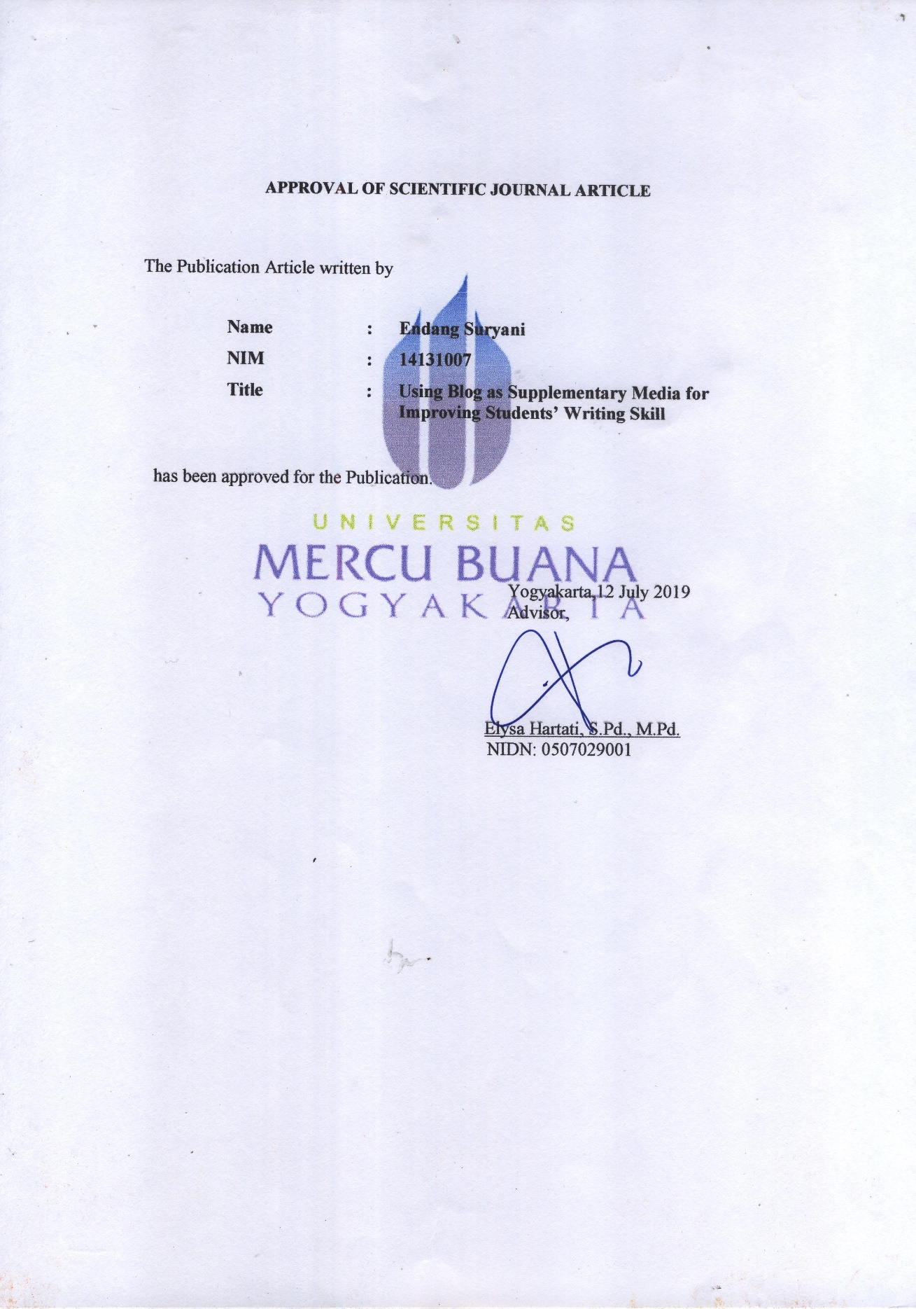

**Using blog as supplementary media for improving students’ writing skill**

Endang Suryani1, Elysa Hartati2

English Language Education, Faculty of Teacher Training and Education,

Universitas Mercu Buana Yogyakarta, Indonesia

[endangsuryani07@gmail.com](mailto:endangsuryani07@gmail.com)1, [hartatielysa@gmail.com](mailto:hartatielysa@gmail.com)2

|  |  |  |  |
| --- | --- | --- | --- |
| ARTICLE INFO |  | **ABSTRACT** |  |
| Article history  Received  Revised  Accepted |  | **This study aimed at investigating the implementation of blog as supplementary media during teaching and learning process and finding out the impacts of using blog as supplementary media in improving students’ writing skill. Classroom Action Research (CAR) was applied as the research method. The subject of this study was 33 students of the second year of the state middle school in Gunungkidul. Qualitative and quantitative data were used in analyzing the data. The result of the study showed that there was improvement of students’ writing skill, which could be seen from their mean score of pre-test, post-test 1, and post-test 2. Students’ average score on pre-test was 49.1, the mean score of post-test 1 was 74.6, while the average score of post-test 2 was 79.2. The students had passed the minimum mastery criterion on the post test. The data from the questionnaire showed that blog could help students in improving their writing skill. In addition the result of interview and observation indicated that the students were motivated and performed positive behavior in the class. In conclusion, students’ writing skill was improved by implementing blog as supplementary media during the teaching and learning process. Hence, it could be concluded that blog is an appropriate supplementary media in improving the students’ writing skill.**  [https://licensebuttons.net/l/by-sa/3.0/88x31.png](http://creativecommons.org/licenses/by-sa/4.0/)This is an open access article under the [CC–BY-SA](http://creativecommons.org/licenses/by-sa/4.0/) license. |  |
| **Keywords**  Blog  Supplementary Media Writing Skill  Classroom Action Research |  |

1. **Introduction**

Writing, which belongs to productive skill, can be described as an intellectual activity of finding the ideas and thinking about the way to express and arrange them into a statement that is clear to be understood by the people Nunan (2003:88). It can be defined that writing is kind of people’s activity on expressing their thought by composing some sentence in a written form. In addition, writing is a way to produce language (Meyers, 2005:2) which is found as the physical and mental act (Nunan, 2003:88). It means that the product of writing is language in a form of letters which can be edited to inform others about the writer’s thought. As claimed by Leki (1989:4), writing is communicating. Good writing gets your ideas out of your head and into a reader’s head without any losing or distorting of those idea. It means the communication through writing, can be successfully done if the writer’s idea can be sent out in to reader’s idea in complete information. In addition, Bram (1995: 25) stated that the purpose of writing is communication. Messages are delivered through written form between the writer and the reader. In educational field, students are accustomed to have good writing skill.

In order to have good writing skill, motivation in learning English is very basic thing that teacher should build in students. Attention to motivation and empowerment helps to strengthen the learning of students (Slavkin, 2004:4). It means that, if the students are fully motivated in the teaching and learning process, they will have much more energy and enthusiastic to learn, hence the aim of the learning can be successfully achieved. Digitalize learning material is one way to improve the students motivation. Celce-Murcia (2002) in Saeedi (2016) suggests that using media in the classroom serves as an important motivator. This statement shows how great the influence of the digital media in boosting the student’s motivation. In addition, Widyawan and Hartati (2016) say that in order to improve students’ ability, the use of media are very needed during teaching and learning process. Furthermore, supplementary tools or media brings advantages in supporting the teaching and learning environments as has investigated in many studies (Uzun, 2015). On this technological era, learners will be more engaged in the learning process which included the use of technology.

Blog is one of social software that allows people to build community and to share ideas in the internet. According to Dudeney and Hockly (2007: 86), a blog, short term of weblog is essentially a web page with regular diary or journal entries. As stated by Stanley (2005) in Zhang (2009), there are some benefits brought by applying blog in the classroom, such as to provide a real audience for students’ writing, to provide extra reading practice, and to encourage students to participate more in the learning process. In addition, Alsubaie and Madini (2018) say that blog is one of the internet utilizations which provide large amounts of advantages in foreign language learning. This statement means that a blog is a web page in the internet that can be utilized to share ideas in a form of writing content. Teacher can use blog to give materials, authentic example of writing project, and media to publish students’ writing assignments. Pinkman (2005) in Fageeh (2011) says that in language learning, blog has been experimentally used as tools to develop writing and reading comprehension skill; implications indicate that although blogging should not replace face-to-face interaction, it may provide a practice environment where students can think, reflect, and create language slowly for a real-life audience. By this statement, it can be concluded that blog will give benefits for the students especially on their writing and reading skill. While a study that is conducted by Hall and Davidson (2007) in Amir (2010) show the evident of the benefits of blog that is by using blog in teaching writing, it improves the students writing skill. Whereas, taken from Kavaliaukiene et al (2006) in Amir 2011, blog becomes a platform that enables the students to learn language in some kinds of task, so they can improve their knowledge. It means that blog give students opportunities to develop their skill, especially on writing skill. According to O’Connor (2011), many adolescent learners today are no longer willing to complete a task that includes complex memorization, but relevant learning will be more attracted them. Therefore, using technology is one of the solutions. Bringing blog in the classroom means giving new challenge to students in practicing their writing in a real-life media.

In fact, students’ writing skills in one of the state middle school in Gunungkidul was low. They often got difficulty in doing writing task. Even there were only around 15% of the students or 5 students out of 33 students who could finish writing task themselves. Most of them could not easily construct a sentence because they lacked the necessary vocabulary items. According to the direct observation, the students seemed like did not have passion in writing. In order to engage the students’ attention in learning, especially in a writing skill, the teacher must use the interesting supplementary media. Hence, this study aimed to find out the problem and seek for the appropriate action to improve students’ writing skill through the use of blog as supplementary media. On this study, the English teacher and students worked as cooperator in order to carry out the use of blog in teaching writing and analyze the impact of the action toward students’ writing skill.

1. **Method**

The study was conducted by adopting the principles of Classroom Action Research (CAR) to investigate the problem, look for solution, and record the changes of students’ writing skill and classroom situation that were influenced by the action. It involved self-monitoring of: planning a change; acting and observing the process and consequences of the change; reflecting on the processes and consequences and then re-planning; reflecting; acting and observing; and so on until the goal or objective is achieved. The main role of action research is to facilitate practitioners to study aspects of practice, whether it is in the context of introducing an innovative idea or in assessing and reflecting on the effectiveness of existing practice, with the view of improving practice (Koshy, 2005). In analyzing the data, there were two types of data which were involved on the study: qualitative data and quantitative data. The qualitative data were collected through observation, questionnaire and interview, while the quantitative data were obtained by writing test.

The participants of this study were the second year of the state middle school in Gunungkidul, Yogyakarta. It was class VIII F, which consisted of 33 students. There were 19 female students and 14 male students. They were in the average age of 13-14 years old. This class was chosen, since the students’ ability was lower than the other classes. The study was conducted at the second half semester in the academic year of 2018/2019.

The procedure of action research is done continuously through cycles. Each cycle is initialized by planning the action after investigating problems in the classroom. Reflecting stage is conducted after finishing the action and the observation. This reflection is very essential. In this stage, the data were analyzed in order to find out if there is still unsolved problem appear during the research and at the final result. The cycle of action research steps can be visually seen as follows:

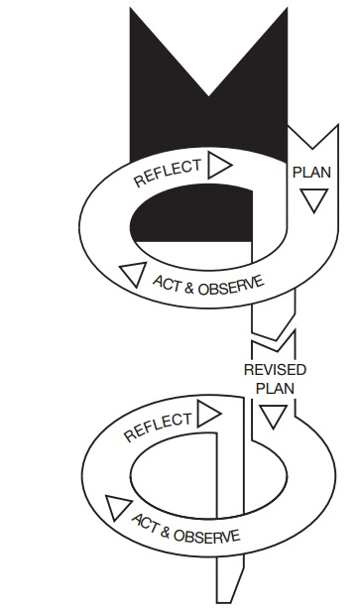

**Cycle 1**

**Cycle 2**

Figure 1 The Individual Aspects of Action Research (Kemmis and McTaggart, 2000 in Koshy, 2005:4)

1. **Finding and discussion**
   1. **The Preliminary Study**

The preliminary study was the stage where pre-observation was done to know the students condition and prepared the action of the study. On this preliminary study, the observation was conducted during the practical teaching or *Praktik Pengenalan Lapangan 2* (PPL 2). After that, the questionnaire was distributed and interviewed some students was conducted to get the data.

The observation was conducted during practical teaching(PPL 2) on August 1st – August 31st 2018. The purpose of the observation was to get the pilot data which showed students writing ability and their participation during the teaching and learning process. From the observation, it can be seen that most of the students had low ability in writing. It indicated from how the faced and did the writing task. They got difficulty in doing the task. There were only 15% or 5 students out of 33 students who could do the task themselves. Mostly, the students had limited vocabulary items which caused them difficult to construct sentences.

The questionnaire was distributed to the students to confirm the identified data which was found on the observation. It was done on October 12th, 2018. There were twenty (20) multiple-choice questions on the questionnaire. Since the research would focus on writing, the questions given on the questionnaire were mainly related to the writing to know the students interest and ability in writing. From the questionnaire analysis, it was shown that most of students agreed that writing skill is important. Even, more than fifty percent (68.75%) of the respondents said that writing is fun. At the other hand, the result also showed that 62.5% or 20 of 32 students considered that they have low ability in writing. Related to the use of media, there were only 12.5 % or 4 students out of 32 students said that their teacher ever used article from blog as the input or example of the writing project. In fact, there were 63% of the respondent wanted their teacher used article from blog as the input of the writing.

The pre-test was conducted on April 4th, 2019. On this pre-test the students were instructed to write their past personal experiment in a recount text. Based on the result of the pre-test, the data showed that the average score was 49. All of the students’ score were lower than the KKM (Minimum Mastery Criterion) which was 70.

Based on the observation, questionnaire, interview, and the result of pre-test, it was identified that students’ writing skill should be improved. Therefore, blog was used as the teaching-learning media during the writing class

* 1. **Implementing CAR**

Prior implementing CAR on the planning stages, some documents such as syllabus, lesson plan, and materials were prepared. Continuing the planning, the action of cycle one was scheduled in two meetings: on Friday 5th and Tuesday 9th April 2019. Blog played a role as the supplementary media which provide the materials for students. Besides, it was also used as the submission media. Post-test I was conducted on Thursday, 11 April 2019 at 13.00-13.40. Based on the calculation, students’ average score of writing skill on the Post Test I was 74.6. The improvement of students’ writing skill from pre-test to Post Test I was 87%. There were only four students who did not pass KKM.

There were strengths and weaknesses of the action in cycle one. The strengths were: the introduction of new supplementary media: blog, the learning activity could engage the students’ enthusiasm, most of the students were able to produce good writing, and the mean score was improved. At the other hand, the weaknesses were: few students still got sleepy, confused, and busy with their friends. These weaknesses of this first cycle were indicated from the activity in which blog was used only as the input media to give some materials and as the final output media to publish students’ project. In addition, in this cycle the students were not actively work through blog. Therefore, the action was continued to the next cycle to improve students’ participation during the teaching and learning process.

In summary, the improvement of the students’ learning and achievement can be drawn as in the Table 1.

**Table 1 The Summary of Students’ Improvement on Learning and Achievement in the End of Cycle 1**

|  |  |  |
| --- | --- | --- |
| **Data Source** | **Before the Action** | **After the Action** |
| * Observation * Questionnaire * Interview * Pre-test * Post Test 1 | 1. Teaching and learning process  * Teacher did not give enough input for writing. * Only few times teacher used media on the teaching and learning process. * The students did not pay full attention to the teacher.  1. Writing ability  * The students only wrote main ideas and little supporting details. * The text organization was not clear. * The students had limited range of vocabulary and used it improperly within a context * There were frequent errors in the used of tenses, agreement, word order, and preposition. * There were frequent errors of spelling, punctuation, and capitalization. | 1. Teaching and learning process  * Teacher gave input from blog. * Blog was used as supplementary media to give example and to publish students’ writing project. * Most of students pay attention during teaching and learning process.  1. Writing ability  * Students added more details on their writing in longer paragraph. * The students’ arrangement of the text was better. * The word choice was better in context. * There were still frequent errors in the used of tense and word order. * There were still some errors of punctuation and capitalization. |
| **Test Score** | The average score of Pre-Test: 49.1 | The mean score of Post Test I: 74.6 |
| **Problem to Solve** | 1. There were monotonous activities in writing. 2. There were lacks of interesting media during teaching writing. | 1. Students’ participation need to be improved. 2. There were still some students who got sleepy, busy with their friends, and confused with the instruction. 3. There were still little problems found on students’ writing project. |

From the same competence, the lesson plan was created. Based on the reflection on cycle one, it was planned to give the students more challenging activities. The action of cycle two lasted in two meetings, it was on Tuesday 16th April 2019 at 08.30-09.50 and Thursday 18th April 2019 at 11.30-13.40. In this cycle, the students were asked to work actively on blog to look for some recount text by using their mobile phone. In addition, they had to analyze the recount text. They should mention the structure, time signal, conjunction, and wrote the function of the text. Besides, more challenging activities were given also to the students. It was re-arranging a recount text.

Finally, the Post Test II was conducted at 13.40-14.20 at the same day. Based on the data analysis, students’ average score of writing skill on the Post Test 2 was 79.2. On this Post Test II, all of the students who joined the test could pass the minimal mastery criterion (KKM). The percentage of students’ writing score improvement from post-test I to post-test II was 15%. Based on the result of the Post Test II, it could be concluded that students’ writing skill was improved. On the reflection stage, the result of each action was discussed. The English teacher agreed that students had improvement on their writing ability and their motivation in learning which showed from their participation on the teaching and learning activity. Hence, it was decided to stop the action. It means, there were two cycles used on the study.

The summary of students’ learning and achievement improvement on cycle two is shown on the Table 2.

**Table 2 The Summary of Students’ Improvement on Learning and Achievement in the End of Cycle 2**

|  |  |  |
| --- | --- | --- |
| **Data Source** | **Before the Action** | **After the Action** |
| * Observation * Post Test 1 * Post Test 2 | 1. Teaching and learning process  * Teacher gave input from blog. * Blog was used as supplementary media to give example and to publish students’ writing project. * Most of students pay attention during teaching and learning process.  1. Writing ability  * Students added more details on their writing in longer paragraph. * The students’ arrangement of the text was better. * The word choice was better in context. * There were still frequent errors in the used of tense and word order. * There were still some errors of punctuation and capitalization. | 1. Teaching and learning process  * Blog was also used as a source to look for related articles to be analyzed to get more students’ participation actively. * The students performed better participation during teaching and learning process. * The students were given more challenging activities. * The students did the task eagerly. * They students presented their job confidently.  1. Writing ability  * The students could write a text in better quantity and quality. * The texts were much better organized and could be smoothly followed. * The students had more vocabulary to use in proper context. * The students produced correct form of past tense. The errors of word order could be reduced through students’ experience. * There were only minor errors of punctuation. |

(continued to page 9)

(table 2 continued)

|  |  |  |
| --- | --- | --- |
| **Test Score** | The average score of Post Test I: 74.6 | The mean score of Post Test II: 79.2 |
| **Problem to Solve** | 1. Students’ participation need to be improved. 2. There were still some students who got sleepy, busy with their friends, and confused with the instruction. 3. There were still little problems found on students’ writing project. |  |
| **The final result of the research:**   1. Teaching and learning process:  * Students’ performed better behavior during teaching and learning activity. * Students’ participation was improved significantly. * The students kept awake and enthusiasm during learning process. * The students were happy to write and enjoyed both group and individual project. * The students were fully motivated to learn and to write.  1. Writing skill:  * *Developing the idea/ content.* The students could write a text in better quantity and quality. * *Organizing the text.* The texts were much better organized and could be smoothly followed. * *Vocabulary mastery.* The students had more vocabulary to use in proper context. * *Language use.* The students produced correct form of past tense. The errors of word order could be reduced through students’ experience. * *Mechanics.* There were only minor errors of punctuation. | | |

To show that students’ writing score was improved after the study, it can be seen from the chart of Figure 2. It presented the score result of pre-test, post-test I, and post-test II.

**Figure 2 The Average Score of Each Test**

From Figure 2, it can be seen the average score of each test of the study was improved significantly. The average of pre-test was 49.1. After implementing the action in cycle one, post-test I then conducted. The result of post-test I was 74.6. After that, the implementation of cycle two was conducted and the students’ average score of post-test II was 79.2.

In addition, Figure 3 showed the percentage of students who passed KKM of pre-test, post-test I, and post-test II.

**Figure 3 Percentages of Students Who Passed KKM**

Note:

|  |  |
| --- | --- |
|  | There was no student who achieved KKM on Pre Test, so it was not shown on the figure. |
|  | There were 87% students who achieved KKM on Post Test I. It was 27 students out of 31 students who joined the test could achieve KKM. |
|  | There were 100% students who achieved KKM on Post Test II. It was 31 students who joined the test and all of them could achieve KKM. |

From the study, the implementation of blog as supplementary media on teaching and learning activity got positive value and enthusiasm of the students. After conducting the action, the questionnaire was distributed. From the analysis of the questionnaire, it presented that students felt blog help them in improving their writing ability. Besides, they said that the technique used during the action by utilizing blog as a media made them happy and enjoyed the learning. In addition it could motivate them also. Finally, it could be concluded that in this case, blog is an appropriate supplementary media in improving the eighth graders’ writing skill.

1. **Conclusion**

The study shows the implementation of blog as supplementary media in teaching writing. Blog could be used as the input, which meant to give students example of real content of writing. As an input, it was used also as references of the materials given. Besides, it was used also the submission media where students could publish their writing project on blog. It gave a lot of opportunity for students to explore their knowledge. By using blog as a media, they had not only text book as the main source, but also blog. It supported them in learning using technology, so they could use their smartphone for fun learning.

The study also shows the great impacts brought by implementing blog during teaching and learning process. Students’ writing score was significantly improved after the action. In addition, the use of blog gave positive value to the students. They became active and independent learners who were fully motivated in learning. Besides, they performed a good confidence in which they were not only able to write or do the assignment, but they were interested also in presenting their job to the class. It caused most of the students could participate well during the teaching and learning process.

Finally, blog can effectively be used as supplementary media in teaching writing. Having range of advantages that allows blog facilitates the learning process, blog can help to improve students’ writing skills.

**References**

Alsubaie, Amal and Madini, Abeer Ahmed. (2018). *The Effect of Using Blog to Enhance the Writing Skill of English Language Learners at a Saudi University.* Global Journal of Educational Studies, ISSN: ISSN 2377-3936, 2018, Vol. 4, No. 1Amir, Zaini., et al. (2011). *Blogs in Language Learning: Maximizing Students’ Collaborative Writing.* Malaysia: Elsevier Ltd.

Amir, Zaini., et al. (2011). *Blogs in Language Learning: Maximizing Students’ Collaborative Writing.* Malaysia: Elsevier Ltd., Journal. 1877-0428

Bram, Barli. (1995). *Write Well.* Yogyakarta: Kanisius

Dudeney, G. and Hockly, N. (2007). *How to teach English with Technology*. Harlow: Pearson Longman

Fageeh, Abdulaziz Ibrahim. (2011). *EFL Learners’ Use of Blogging for Developing Writing Skill and Enhancing Attitudes towards English Learning: an Exploratory Study.* Journal of Language and Literature, ISSN 2078-0303, Vol. 2. No. 1

Koshy, Valsa. (2005). *Action Research for Improving Practice*. London: Paul Chapman Publishing

Leki, Ilona. (1989). *Academic Writing: Techniques and Tasks.* New York: St. Martin’s Press

Meyers, Alan. (2005). *Gateways to Academic Writing.* New York: Longman

Nunan, David (2003). *Practical English Language Teaching, First Edition.* Singapore: McGraw-Hill Companie

O’Connor, Marian (2011). *The Impact of Participating in a Class Blog.* Journal of Classroom Research in Literacy. Vol. 4, 2011

Saeedi, Zari. (2016). *The Application of Technology in Teaching Grammar to EFL Learners: The Role of Animated Sitcoms*. Teaching English With Technology Journal, 16(2), 18-39. <http://www.tewtjournal.org>

Slavkin, Michael L. (2004). *Authentic Learning.* Oxford: ScarecrowEducation

Uzun, Erman. (2015). *Students’ Attitude towards Edmodo as Supplementary Tool for Higher Education.* Participatory Educational Research (PER) Journal, ISSN: 2148-6123

Widyawan, Kristanto Wahyu and Hartati, Elysa. (2016). *Improving Students’ Speaking Skill by Using Their Spoken Audio Recording in the Middle School.* Journal of English Language and Education, Vol. 2, No.1, June 2016, ISSN: 2541-6421

Zhang, Di. (2009). *The Application of Blog in English Writing.* Journal of Cambridge Studies, Vol. 4, No. 1